Introduction to Cloud Solutions Lab Report
Use this template to document your work as you complete the lab assignment in QA.

Your Information
Your Name: Ronald Johnson
Lab Title: Creating AWS EC2 Instances Using Templates

Instructions
Follow the instructions to answer the questions related to the lab and add the required screenshots. Submit your completed report following the instructions in Canvas.

Section 1
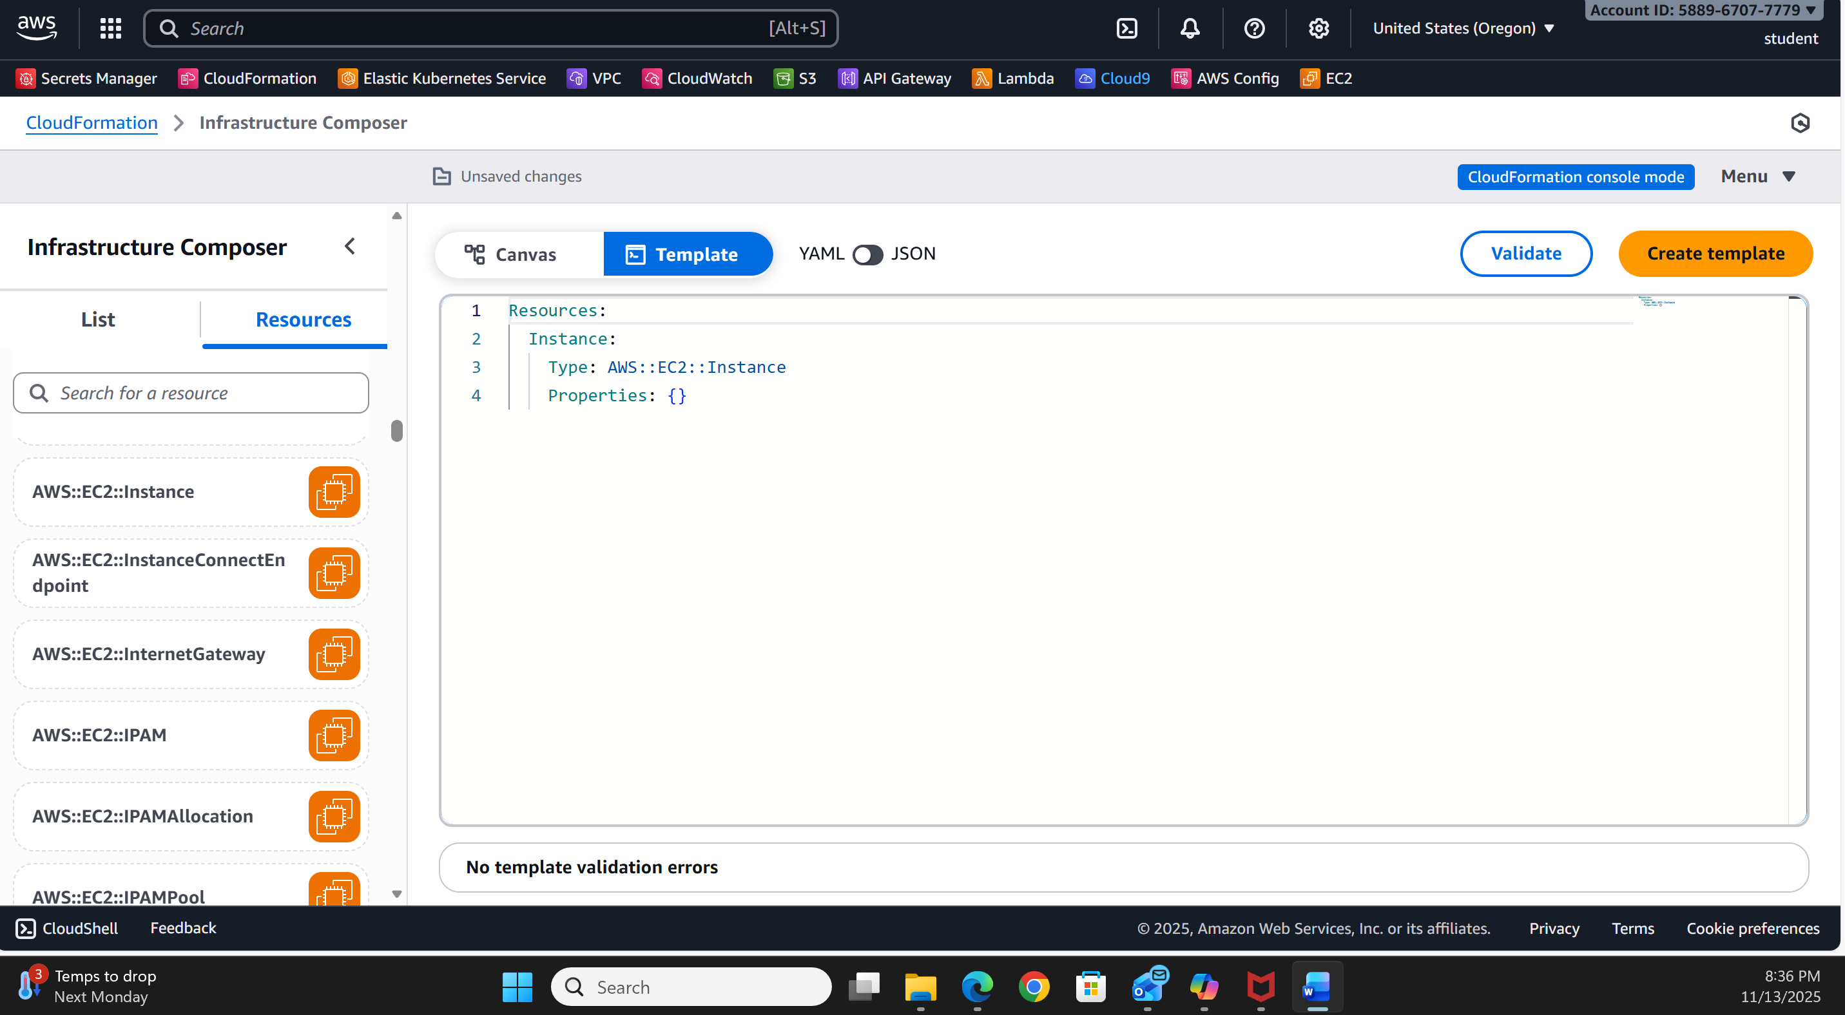

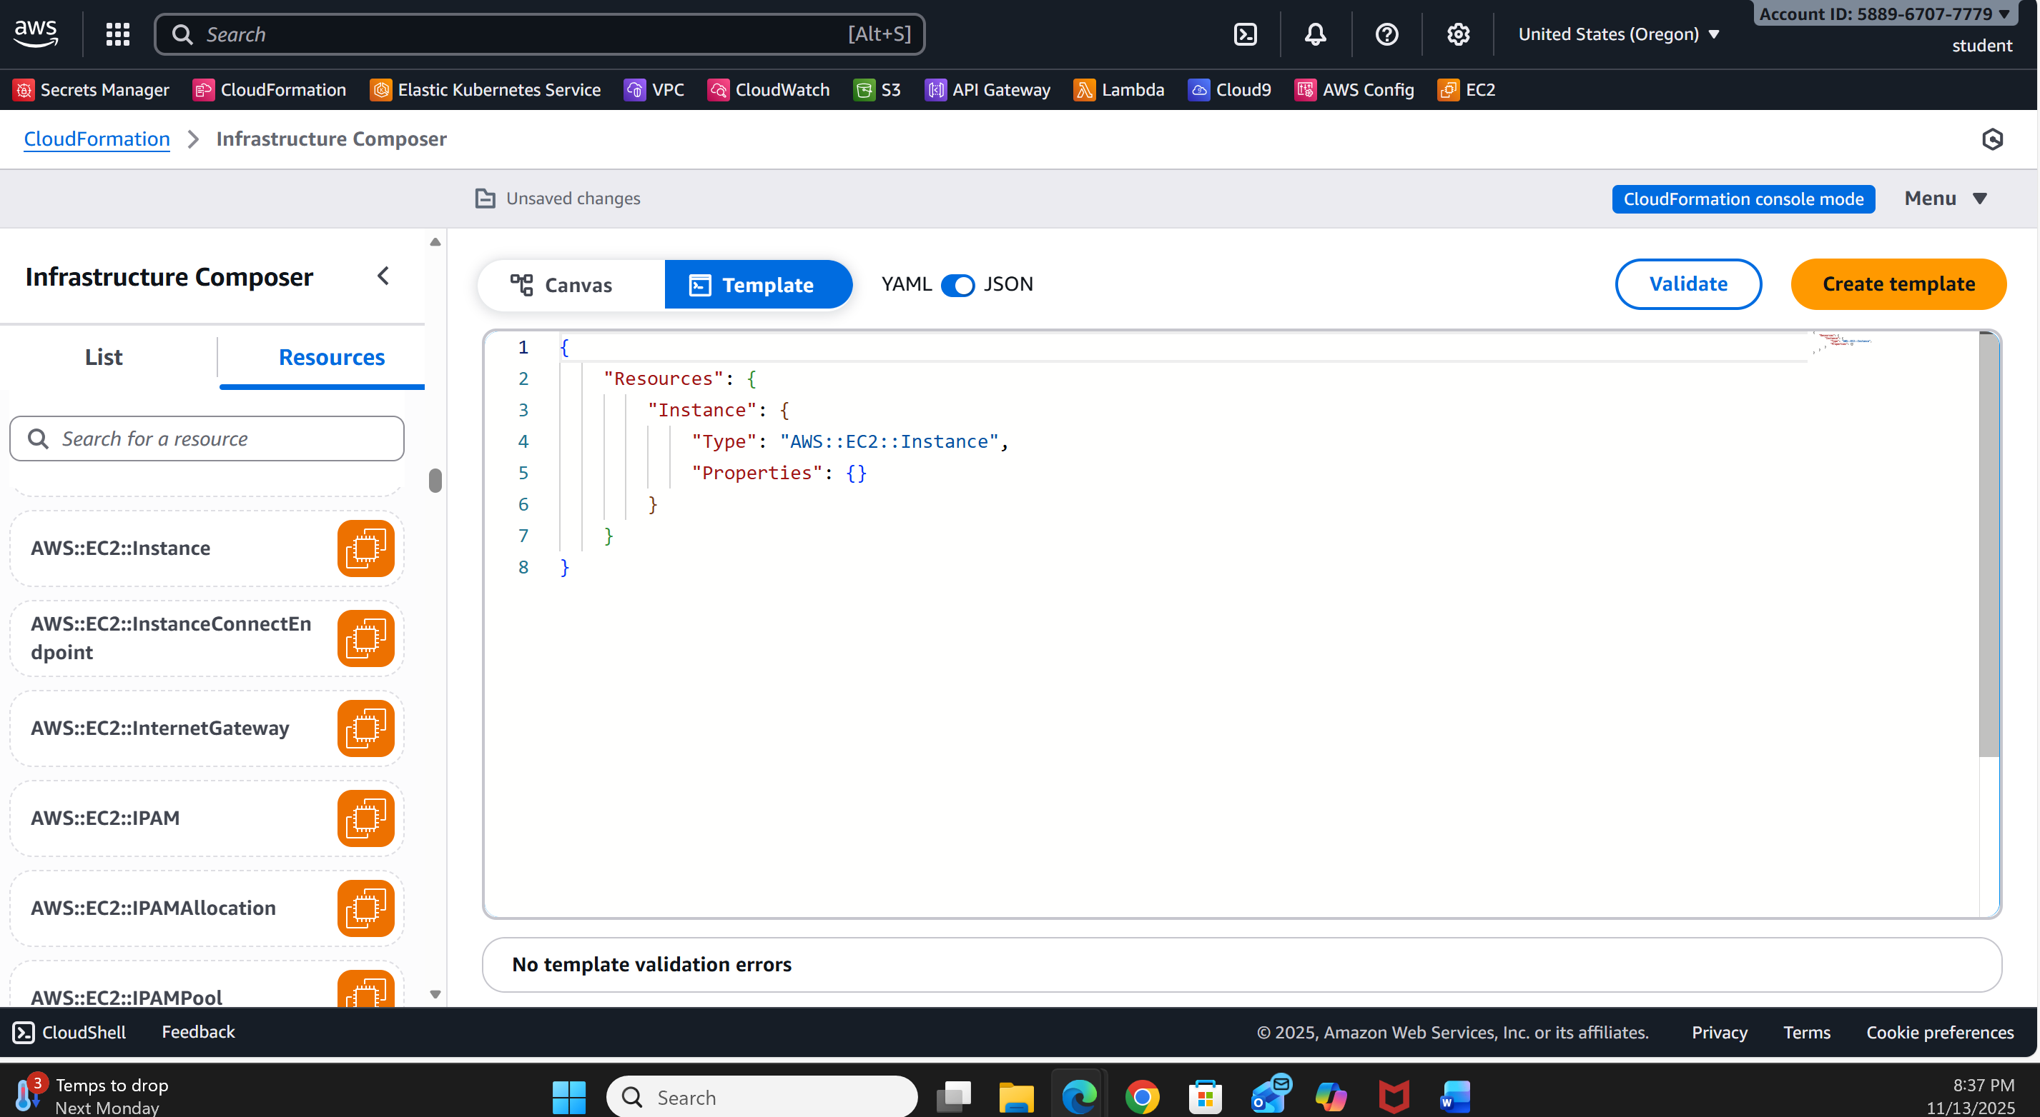
- Step 10: What do the YAML and JSON templates share in common?
YAML and JSON CloudFormation templates have the same structure, meaning, and necessary components. Both formats describe AWS resources similarly. They consist of:
- A mandatory Resources section
- Optional sections like Parameters, Outputs, Mappings, Conditions, and Metadata
- The same types of AWS resources (e.g., AWS::EC2::Instance)
- Identical property names and permissible property values
- The same logical resource names and connections
Although the formatting differs, both formats convey the exact same CloudFormation template content, and AWS handles them the same way.

- Step 10: How do the YAML and JSON templates differ from one another?
While both YAML and JSON convey the same information, they have different syntax and readability:
YAML
- Easier for people to read and write
- Utilizes indentation instead of braces and commas
- Allows comments (# comment) More adaptable and less wordy
JSON
- Employs curly braces {}, brackets [], commas, and quotation marks
- Has strict formatting—every string needs to be quoted
- Does not allow comments More inflexible and more detailed
In summary: YAML is more user-friendly and lenient, whereas JSON is more strict and machine-oriented. Both formats function similarly in CloudFormation; only the syntax varies.
3. Step 14 Screenshot: YAML template with URL
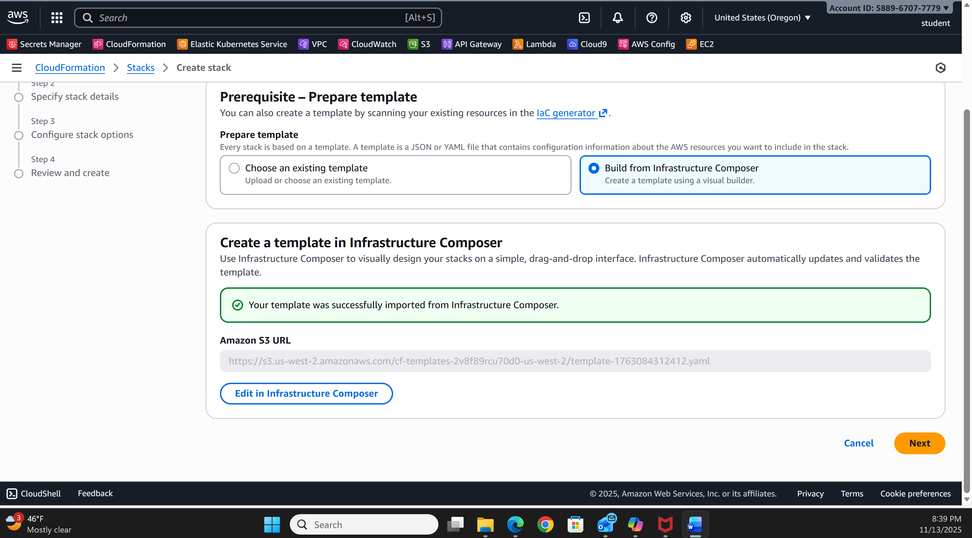
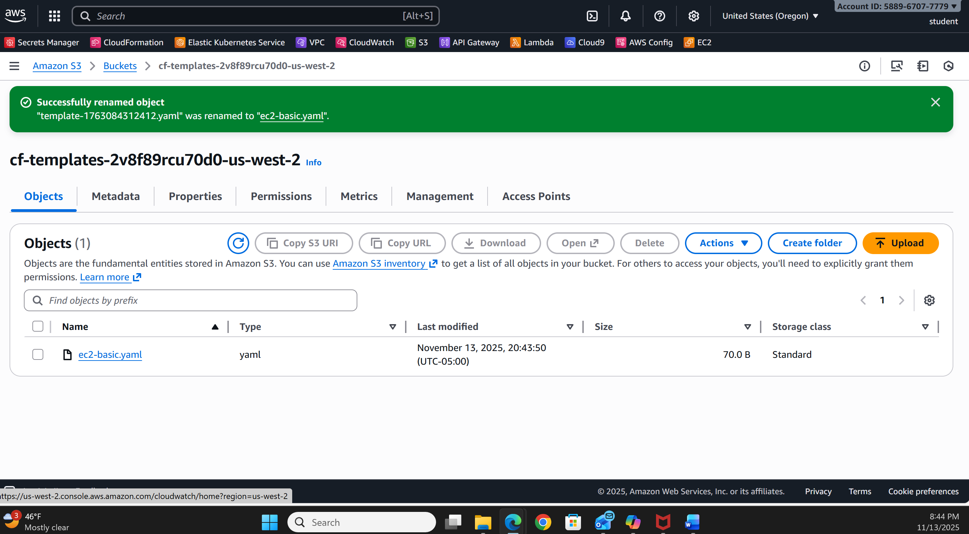
4. Step 30 screenshot: JSON template with URL
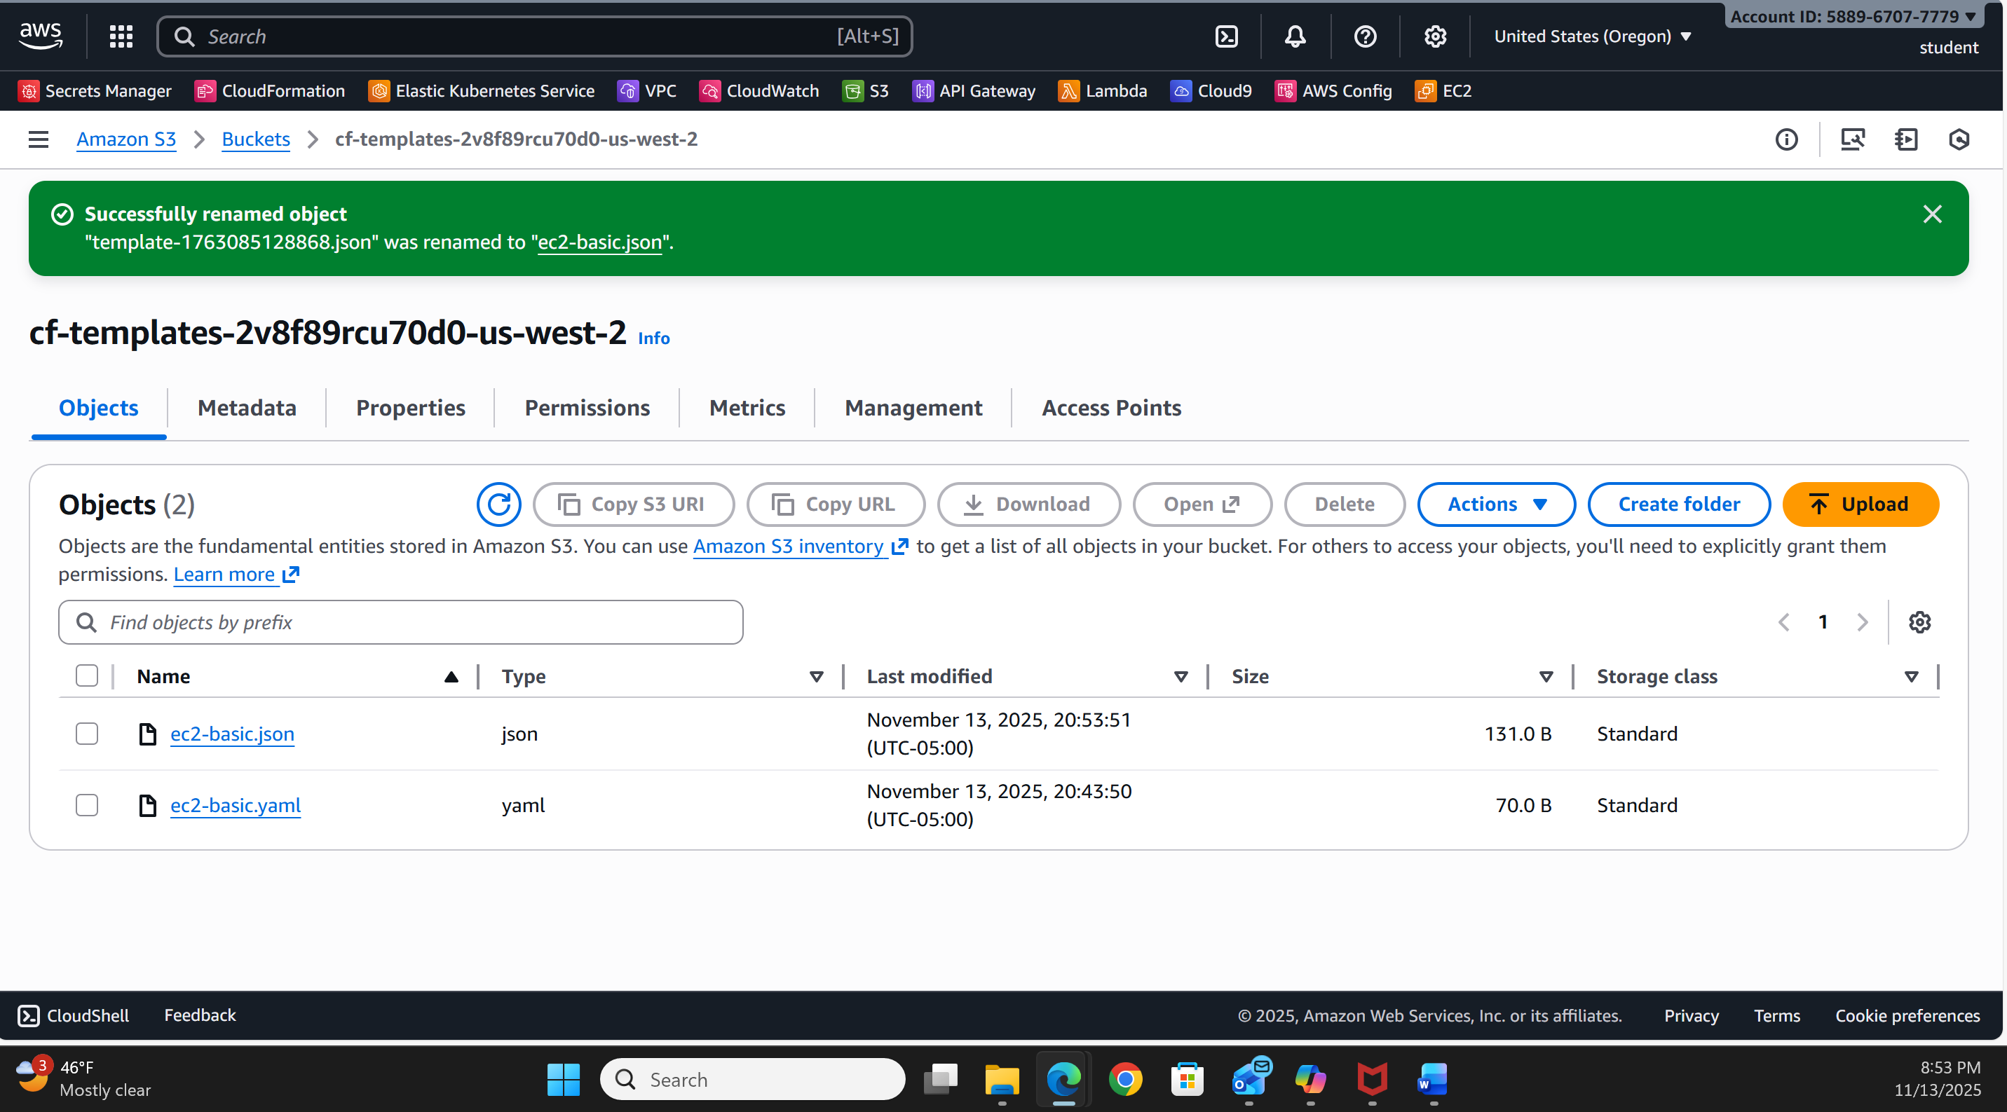

Section 2
5. Step 14: If you received a validation error, what steps did you take to resolve it?
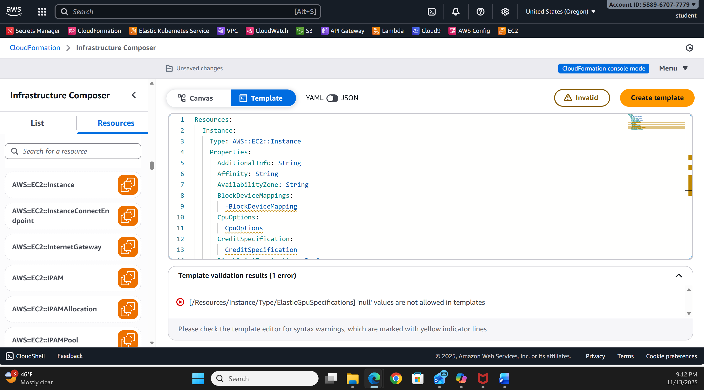

6. Step 14: What do validation errors indicate about the contents of template file?
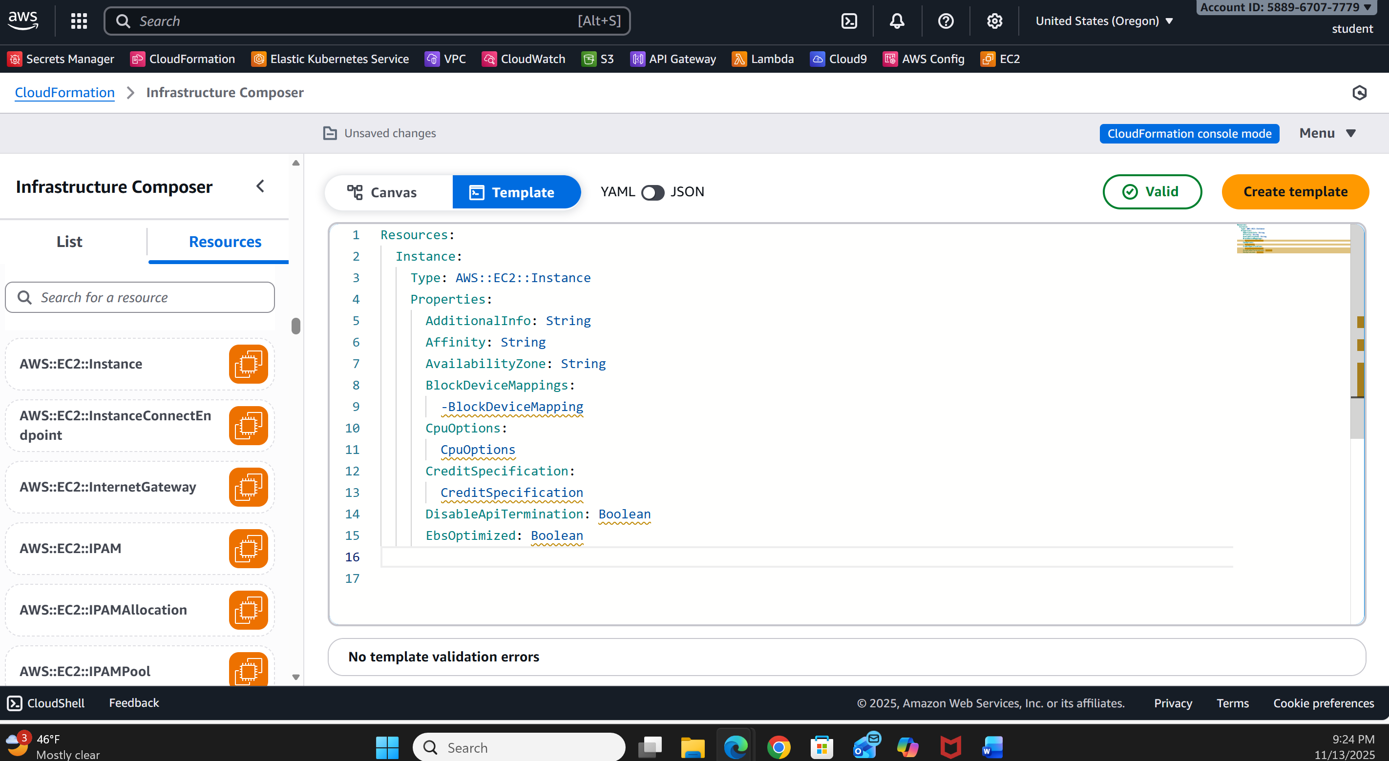

7. Step 17 screenshot: YAML template with URL
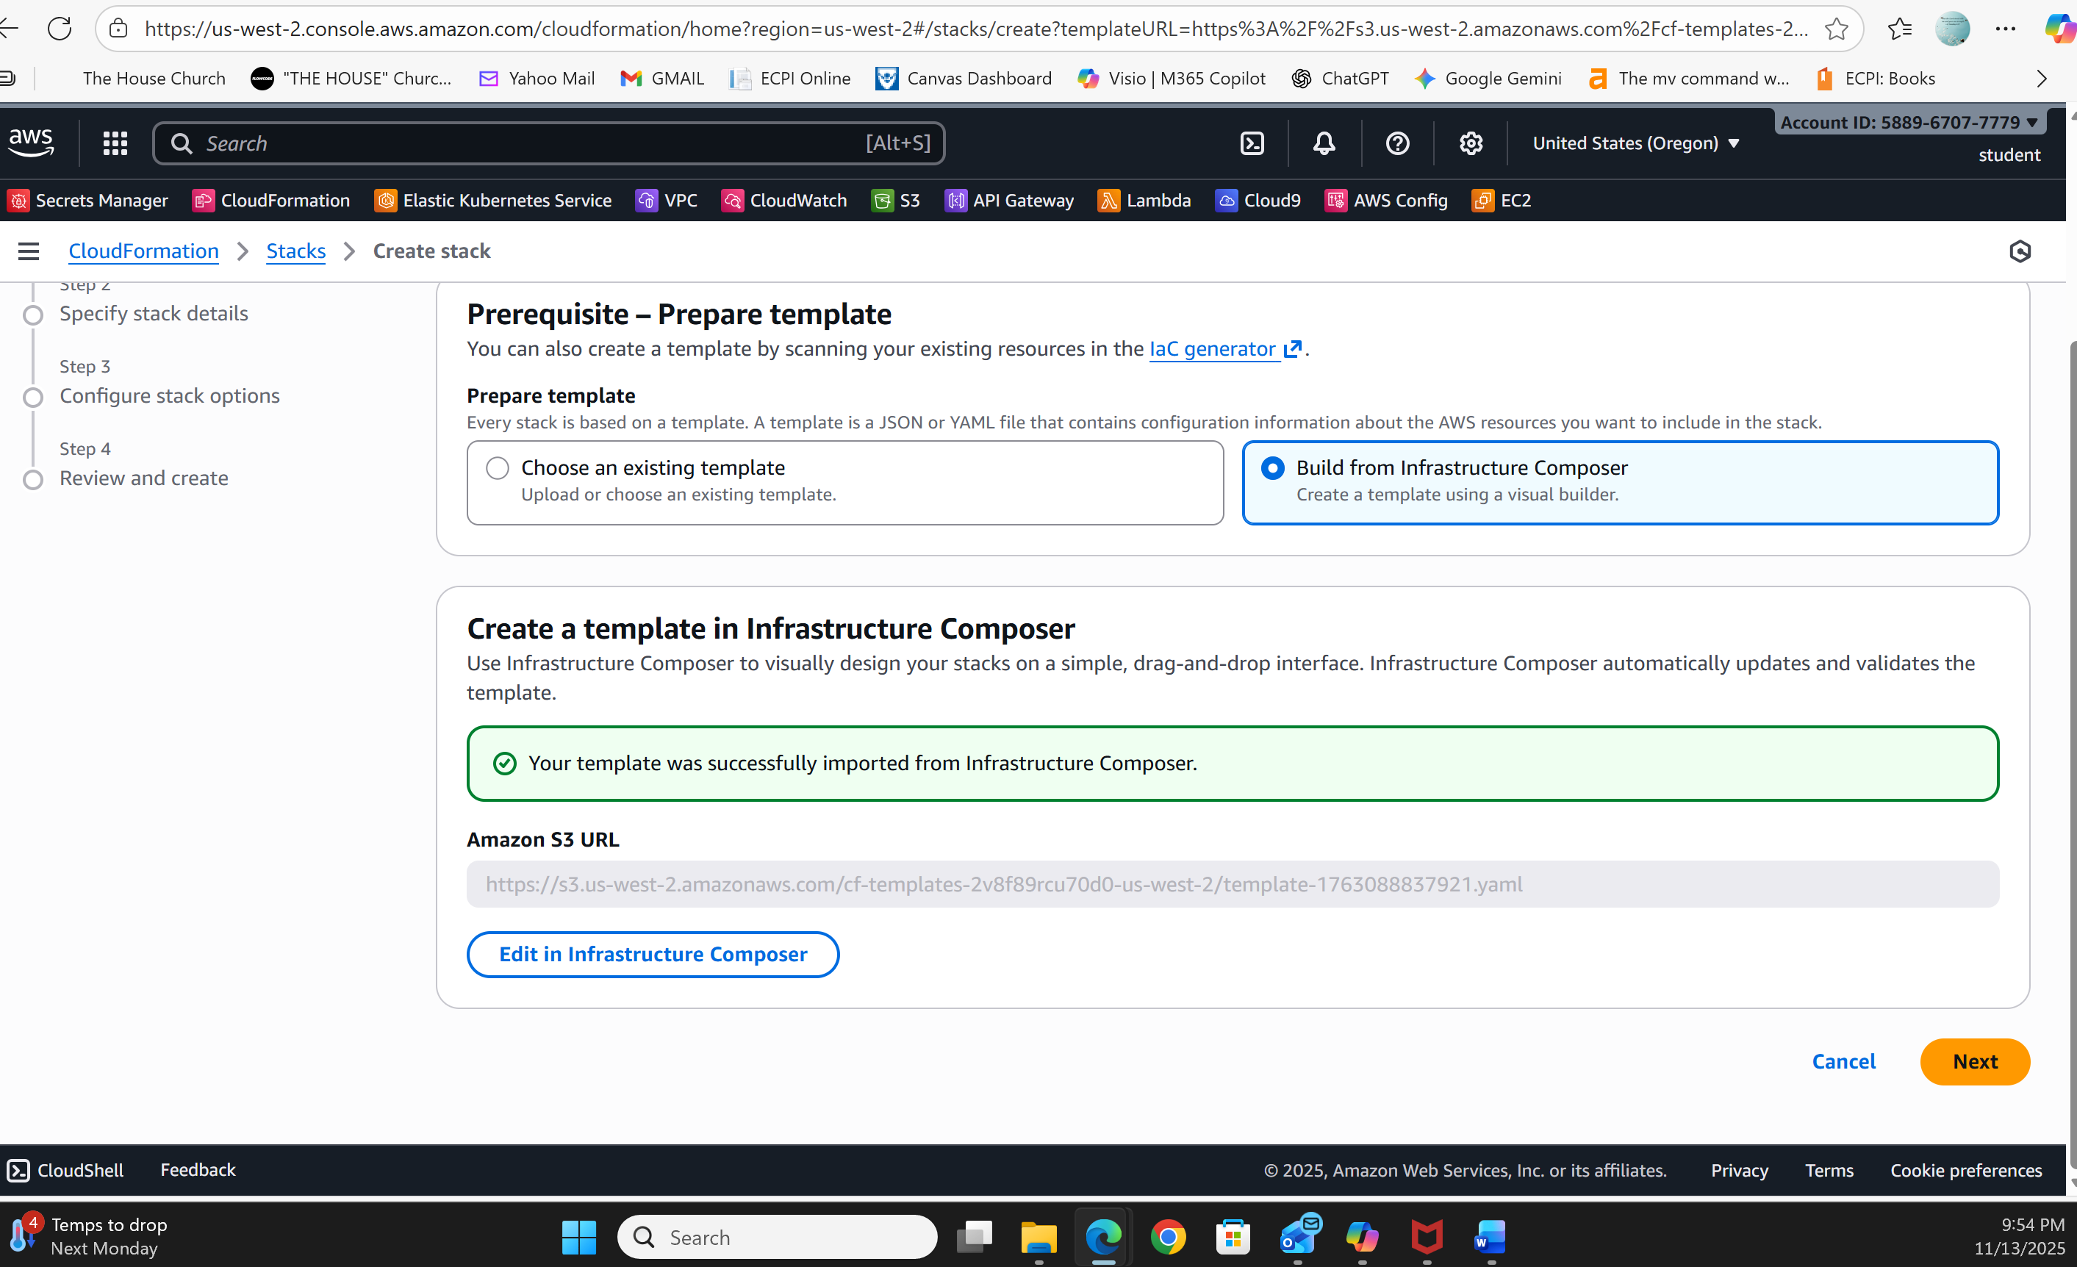

8. Step 28 screenshot: YAML template named stack (include your student ID)
